- Installing Entrust IdentityGuard Soft Token
The following instructions describe how to run through the setup program (IGSoftToken_Win.msi) to install Entrust IdentityGuard Soft Token.
Pre-installation task
Before installing Entrust IdentityGuard Soft Token, ensure that one of the following is installed on your computer:
- .NET Framework 3.5 with service pack 1, or
- .NET Framework 4, or
- .NET Framework Client Profile

To check:
- Open the list of installed programs as follows:
- On Windows XP, click Start > Control Panel > Add or Remove Programs.
- On Windows Vista or Windows 7, click Start > Control Panel > Uninstall a program.
- In the list of programs, look for Microsoft .NET Framework 3.5 SP1 or Microsoft .NET Framework 4, or Microsoft .NET Framework Client Profile.

If none of these software packages is shown in the list of programs, download Microsoft .NET Framework 3.5 SP1 from http://www.microsoft.com/downloads/en/details.aspx?FamilyID=d0e5dea7-ac26-4ad7-b68c-fe5076bba986 and install it.

Microsoft .NET Framework 3.5 SP1 comes with Windows 7, and might have been installed as part of a Microsoft Update on Windows Vista or XP.
To install Entrust IdentityGuard Soft Token
- Double-click IGSoftToken_Win.msi to launch the setup program.

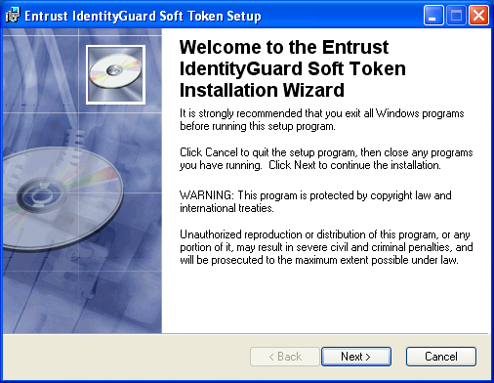

- On the Welcome screen, click Next.

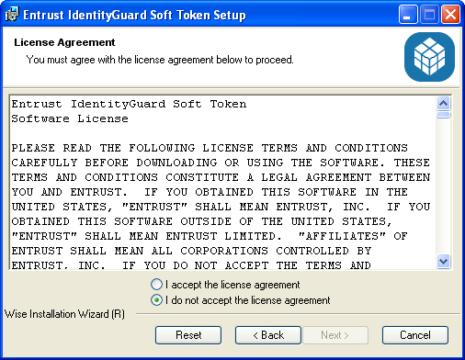

- On the License Agreement screen, select I accept the license agreement if you agree to its terms.
Click Next.

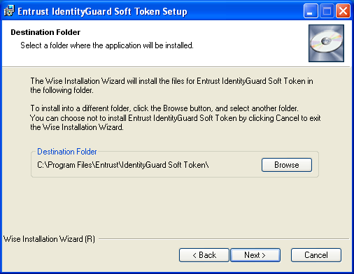

- On the Destination Folder screen, select where you want to install the application. The default location is:

C:\Program Files\Entrust\IdentityGuard Soft Token

Click Next.

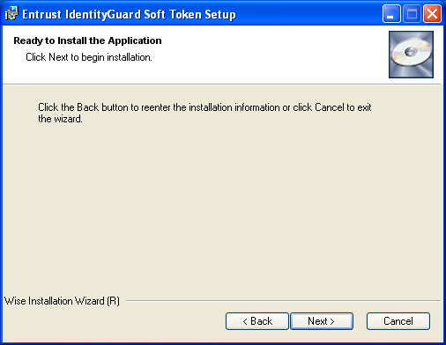

- On the Ready to Install the Application screen, click Next.
The application is installed.

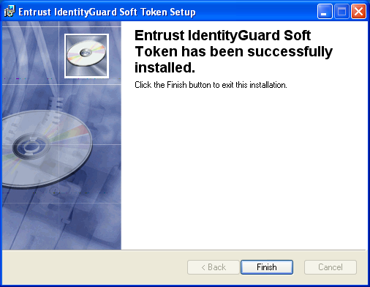

- On the success screen, click Finish.

